LRM001
LoRa® Mini PCIe, 433/868/915MHz
Range : 7Km

L

L

Features

. Mini PCI Express form factor

. 2 u.FL antennas to support 433 or 868 or 915MHz

. Range 7KM

. FTD® 232HL

Specification

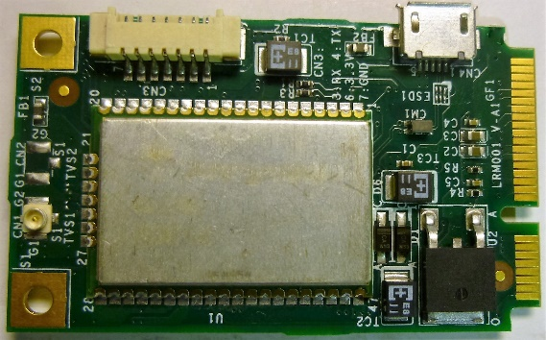
. Compliant with LoRa®

. Mini PCI Express form factor

. 2 u.FL antennas to support 433 or 868 or 915MHz

. Range 7KM

. Data rate 1k bps

. Network type: Star

. Standby current: 0.1mA

. Rx current: 12ma

. Microchip® RN2483 LoRa®

. FTD® 232HL

. RF Output power (maximum) 20dbm

. Receiver sensitivity: -130 dbm

. Support Win 7 and Window 10

. Support Linux : Ubuntu 12.04

. Hardware LoRa® reset

. Dimension: 50 x 29 x 9 mm

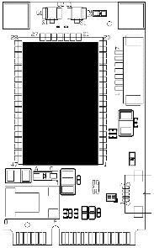
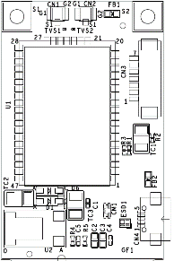
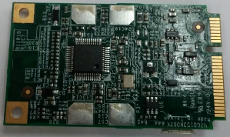

Interface

 |  | LRM001 | LRM002 | LRM003 (April) | LRM005 (May)
Mini PCIe Full Size |  |  |  | 
USB 2.0 |  |  |  | 
UART |  |  | 
M.2 |  |  |  |  | 
433M or |  | Model 433 | Model 433 | Model L | Model L
 | 868M or | Model 868 | Model 868 | Model H | Model H
915M or |  | Model 915 | Model 915 | Model H | Model H

Model Lists: |  |  | Common Specification:
LRM001-433 | Mini PCIe USB 433MHz |  | Operating Humidity | 5% ~ 95% RH
LRM001-868 | Mini PCIe USB 868MHz |  | Operating Temperature | -20º C~ 60 ºC
LRM001-915 | Mini PCIe USB 915MHz |  | Storage  Temperature | -20º C~ 80 ºC
LRM002-433 | UART 433MHz
LRM002-868 | UART 868MHz |  | Packing List
LRM002-915 | UART 915MHz |  | u. FL Antenna Cable  433 or 868 or 915MHz Antenna
LRM003-L | Mini PCIe USB 410 ~525MHz
LRM003-H | Mini PCIe USB 862 ~ 1020MHz

